Molecular Docking simulation and NGS
By Umashree B S
Reg. No. 24L10946

Internship Report submitted to
JSS Academy of Higher Education & Research, Mysuru
In partial fulfilment of the requirements for the Degree
MASTER OF SCIENCE
In
BIOINFORMATICS
Under the guidance of
Dr. Sowmya TN
Assistant Professor

Department of Biotechnology & Bioinformatics

JSS Academy of Higher Education & Research Mysuru– 570015

JANUARY 2026
Department of Biotechnology & Bioinformatics
JSS Academy of Higher Education & Research
(Deemed to be University) Accredited "A⁺⁺" Grade by NAAC

SUBMISSION / EVALUATION CERTIFICATE

This is to certify that this Internship report entitled “Molecular Docking simulation and NGS” has been submitted by Umashree B S to the JSS Academy of Higher Education & Research, Mysuru under the guidance of Dr. Sowmya TN, Assistant Professor, Department of Biotechnology & Bioinformatics, JSS Academy of Higher Education & Research, Mysuru in partial fulfilment of the requirements for the degree of Master of Science in Bioinformatics.
Date:
Controller of Examinations

This is to certify that this Internship report has been evaluated.

Signature of Examiners | 1.  2.
Names: | 1.  2.
Date


Department of Biotechnology & Bioinformatics
JSS Academy of Higher Education & Research
(Deemed to be University) Accredited "A⁺⁺" Grade by NAAC

DECLARATION BY THE CANDIDATE

I, Umashree B S hereby declare that this Internship report entitled “Molecular Docking simulation and NGS” submitted in partial fulfilment of the requirements for the award of the degree of Master of Science in Bioinformatics, is a original record of the work carried out by me under the guidance of Dr. Sowmya TN, Assistant Professor, Department of Biotechnology & Bioinformatics, JSS Academy of Higher Education & Research, Mysuru, Karnataka. This Internship report has not formed the basis for the award of any other Degree/ Diploma/ Associateship/ Fellowship or another similar title of any candidate of any University.

Date:
Umashree B S
Place: Mysuru Department of Biotechnology & Bioinformatics
JSS Academy of Higher Education & Research Mysuru – 570015
Department of Biotechnology & Bioinformatics
JSS Academy of Higher Education & Research
(Deemed to be University) Accredited "A⁺⁺" Grade by NAAC

CERTIFICATE BY THE GUIDE

This is to certify that this Internship report entitled “Molecular Docking simulation and NGS” is a bonafide record of the work done by Umashree B S, Postgraduate student, Department of Biotechnology & Bioinformatics, JSS Academy of Higher Education & Research, Mysuru, under my guidance in partial fulfilment of the requirements for the degree of Master of Science in Bioinformatics.

Date:
Dr. Sowmya TN
Place: Mysuru Department of Biotechnology & Bioinformatics
School of Life Sciences-Mysuru
JSS Academy of Higher Education & Research Mysuru – 570015

SCHOOL OF LIFE SCIENCES - MYSURU
JSS Academy of Higher Education & Research
(Deemed to be University) Accredited "A⁺⁺" Grade by NAAC

ENDORSEMENT BY THE HEAD OF THE DEPARTMENT

This is to certify that this Internship report entitled “Molecular Docking simulation and NGS” is a bonafide record of the work done by Umashree B S, Postgraduate student, Department of Biotechnology & Bioinformatics, JSS Academy of Higher Education & Research, Mysuru, under the guidance of Dr. Sowmya TN, Assistant Professor, Department of Biotechnology & Bioinformatics, School of Life Sciences-Mysuru, JSS Academy of Higher Education & Research, Mysuru, in partial fulfilment of the requirements for the Degree of Master of Science in Bioinformatics.

Date: PROFESSOR & HEAD
Place: Mysuru School of Life Sciences, Mysuru &
Life Sciences Departments
JSS Academy of Higher Education & Research Mysuru – 570015

Department of Biotechnology & Bioinformatics
JSS Academy of Higher Education & Research
(Deemed to be University) Accredited "A⁺⁺" Grade by NAAC

CERTIFICATE BY THE DEPARTMENT COORDINATOR

This is to certify that this Internship report entitled “Molecular Docking simulation and NGS” is a bonafide record of the work done by Umashree B S, Postgraduate student, Department of Biotechnology & Bioinformatics, JSS Academy of Higher Education & Research, Mysuru, under the guidance of Dr. Sowmya TN in partial fulfilment of the requirements for the degree of Master of Science in Bioinformatics.

Date: Dr. Gopenath T S
Place: Mysuru Department of Biotechnology & Bioinformatics
JSS Academy of Higher Education & Research
Mysuru – 570015

Department of Biotechnology & Bioinformatics
JSS Academy of Higher Education & Research
(Deemed to be University) Accredited "A⁺⁺" Grade by NAAC

CERTIFICATE OF ANTI-PLAGIARISM CHECK
It is certified that this Internship report titled “Molecular Docking simulation and NGS” by Umashree B S, Postgraduate student, Department of Biotechnology & Bioinformatics, JSS Academy of Higher Education & Research, Mysuru, has been subjected to anti-plagiarism check.
We undertake the following:
- The research work submitted is original.
- No sentence, table, paragraph, or section has been copied verbatim from any other resource unless it is placed under quotation marks and duly referenced.
- There is no fabrication of data or results which have been compiled.
- There is no falsification by manipulating research materials, equipment, or processes.
- The Internship report has been checked using Anti-plagiarism web tool “TURNITIN” and found within limits as per the anti-plagiarism guidelines of JSS AHER, Mysuru.
- The similarity index for the Internship report is as follows:

% Similarity index
Total continuous words

 | Name | Signature
Guide: | Dr. Sowmya TN
Student: | Umashree B S

Recommendation/ comments by Department Academic Integrity Panel (DAIP):
 | DAIP | Name | Signature
1. | Chairman
2. | Member
3. | Member Secretary

Institution seal



AKNOWLEDGEMENT
I would like to express my heartfelt gratitude to His Holiness Jagadguru Shivarathri Deshikendra Swamiji and the JSS University in Mysore for their blessings.
I would like to thank Dr. B. Suresh, Pro-Chancellor, JSS Academy of Higher Education & Research, for the constant and continuous support of progressive development and encouragement of this internship.
I thank Dr. Surinder Singh, Vice-Chancellor, JSS Academy of Higher Education & Research, for the persistent support of this internship, progress, and development.
Next, I would like to thank Dr. B. Manjunatha, Registrar, JSS Academy of Higher Education & Research, for the support, and encouragement towards internship.
I express my sincere gratitude to Dr. Sudeendra Bhat R, Controller of Examinations, and Dr. P A Kushalappa, Director of Academics, JSS AHER, Mysuru, for all the support and cooperation throughout my internship.
I would like to thank Dr. Prashant M. Vishwanath, Director of Research, JSS Academy of Higher Education & Research, for the constant encouragement and promotion of this techniques.
I thank Dr. Raveesha K A, Professor, and Head, School of Life Science, JSS Academy of Higher Education & Research, for facilitating, supporting, and encouraging research and science.
I like to express my sincere gratitude to Dr. Gopenath T S, Associate Professor, Coordinator, Department of Biotechnology and Bioinformatics, JSS Academy of Higher Education & Research, Mysore, for his extended support and encouragement throughout my internship.
I would like to thank Dr. Sowmya TN, Assistant Professor, Department of Bioinformatics and Biotechnology - School of Life Sciences, JSS Academy of Higher Education & Research (JSS AHER), Mysuru, Karnataka, for his guidance, extended support and excellent encouragement during my research endeavour.
I would like to thank Dr. Chandan S, Deputy Dean Research and Associate Professor, Department of Bioinformatics and Biotechnology - School of Life Sciences, JSS Academy of Higher Education & Research (JSS AHER), Mysuru, Karnataka, for his guidance, extended support, and excellent encouragement during my research endeavor.
Words fall short of expressing my gratitude to my friends and seniors, without whom my thesis would not have been accomplished successfully.
Last but not least, I am grateful to my family members; this work would not have been possible without their best wishes, cooperation, support, and encouragement.

LIST OF ABBREVIATIONS

SBDD- structure based drug design
ADT- auto dock tool
SDF- structure data file
PDBQT- protein data bank (Q) charge (T) atom type
SMILES- simplified molecular input line entry system
GROMACS-Groningen machine for chemical simulation
RMSD- Root Mean Square Deviation
CSV- Comma separated values
MD- Molecular dynamics
SAM- sequence alignment map
BAM- Binary alignment map
SARS-COV-2- Severe Acute Respiratory Syndrome Coronavirus 2
FASTQC- Fasta Quality control

Key Words: Next-generation sequencing, Simulation, Molecular docking, Linux terminal, databases

ABSTRACT
One method of using computers to simulate the interactions between molecules is called molecular docking. This occurs when a complex is formed by the combination of two or more molecules. We can determine the three-dimensional form of these complexes with the aid of molecular docking. It accomplishes this by examining how the molecules fit together and how firmly they connect to one another. Molecular docking generates a large number of structures, which are then ranked and grouped together using a unique technique. We refer to this instrument as a scoring function. It is a component of the program for molecular docking. Molecular docking is really helpful for comprehending its capabilities and how it operates. For scientists that investigate molecular docking and wish to learn more about the molecules they are dealing with, molecular docking is a useful technique. Docking simulations use the system's total energy to determine the optimal docked conformer. Research on the genetic components of disorders that people are born with is being drastically altered next generation sequencing, or NGS. This approach is quite effective at gathering a lot of information and is reasonably priced. Targeted NGS, for instance, enables us to examine in detail the regions of the genome that are crucial for the illness we are researching. We can benefit from generation sequencing in a few ways. It lowers the price. It speeds up the procedure. Additionally, generation sequencing facilitates computer processing of the data, which is very beneficial because NGS typically generates large amounts of data. Targeted NGS can be a great method for dealing with a phenotypically and genetically heterogeneous disease for which there are known genetic connections, even though it is limited to specific sections of the genome, making it impossible to identify potential novel loci of interest.

TABLE OF COTENTS

Sl.No. | Content | Page Number
1. | Introduction | 1
2. | Tools and Databases | 2
3. | Methodology | 3-5
4. | Results and Discussion | 6-7
5. | Application | 8
6. | Next Generation Sequencing | 8-10
7. | Methodology | 10-11
8. | Results and Discussion | 12
9. | References | 13

LIST OF FIGURES

Sl.No. | Legends of the figure | Page Number
1. | Molecular Docking | 3
2. | Flexible docking | 4
3. | Final result obtained after executing Protein apo simulation | 6
4. | Snapshot of protein apo molecular dynamics simulation in explicit solvent | 6
5 | Snapshot of Grid box created around the Ligand using Auto dock tool | 7
6 | Obtained Docking score | 7
7. | Raw data exported for quality check using FASTQC website | 10
8. | Per base sequence quality | 10
9. | snapshot of sam tools flagstat output | 11
10. | Snapshot of final execution page of NGS | 12
11. | required files which are generated after the execution of pipeline | 12

1. Introduction
Molecular docking is a type of computational modeling that aids in determining the optimal fit between a molecule, such as a ligand, and another molecule, such as a receptor. These two molecules form a team when they cooperate. We can determine the strength of their tie by seeing how well they fit. We can also determine how stable they are and how much energy they require to remain together. To do all of this, molecular docking makes use of a tool known as a scoring function. Understanding how molecules, such as ligands and receptors, interact with one another is greatly aided by the docking scoring function. These days, molecular docking is widely used to determine how tiny compounds, such as those that can be utilized as medications, fit into their target, which is typically a protein, carbohydrate, or nucleic acid. Finding out how these tiny molecules might attach to their target is the aim of docking. In order to comprehend how molecular docking can help us learn more about the molecules and their targets, this provides some information on molecular docking and how it interacts with the target. rational drug design (structure-based drug development) developing novel drugs with increased specificity and efficacy We require a strategy to comprehend the behavior of biological macromolecules. This technique is known as molecular dynamics, or MD for short. The foundation of molecular dynamics is mechanics. Therefore, we apply Newton's equations of motion. These formulas assist us in determining the macromolecules' location and velocity. These formulas are applied to the macromolecules. In this manner, we may see the motion and behavior of biological macromolecules. Biological macromolecules can be studied using molecular dynamics. every atom in the system under study. As a result, MD simulations provide a more realistic picture of protein movements and perform a more thorough conformational search than molecular docking techniques. The Next Generation Platforms for sequencing differ greatly from one another. They employ methods for DNA sequencing. We don't need to delve into every detail because all Next Generation Sequencing platforms provide the fundamental functions. They simultaneously examine millions of DNA fragments. To put these pieces together, we employ computer programs. This is accomplished by comparing each component to the DNA that we are already aware of. Three billion pieces make up human DNA. Every one of these components is examined occasionally. This gives us knowledge and reveals aspects of the DNA that we were not anticipating. We can learn a great deal about DNA through generation sequencing. NGS can be used to sequence complete genomes or limited to particular regions of interest, such as small numbers of individual genes or all 22,000 coding genes (a whole exome).

Tools and Databases used for Molecular Docking and Simulation
Protein: 1UBQ, Ligand: Caffiene
Linux operating system: comfortable working environment for docking, simulation and NGS
PDB: To get the data for docking as a receptor and ligand in legacy pdb format
Pymol: To visualize the protein, and the active sites which have binded the ligand
mgl tools: is a file which consists of the Autodock tools, python molecular viewer (PMV) which helps for the 3D visualization and analysis.
Bin files: In this file where the Autudock tools are present where we have to open the Terminal for further analysis
Autodock tools: like Autodock vina provides tools to prepare protein
PubChem: helps to retrieve the 3D structures in SDF (structure data file) format
Open babel: tool that used to convert the SDF files to PDBQT format using the Smiles sequence
Smiles: are 1D or 2D representation of the chemicals like Ligand

Simulation
Protein: 1IYT
Ubuntu Linux Terminal: most commonly simulations are executed using the Linux terminal
GROMACS-open-source software which suits for the docking and simulation, it is also a multistep code to perform simulation
Here to run the simulation steps I have used the company manual

NGS
Reference sequence- SARS COVID 2 genome
NCBI- used to retrieve the metadata from SRA, Bio project, Bio-sample and Genome
To generate the files of quality check we use certain environments like Spades, Conda, Prokka and Quast
Here to run the NGS Pipeline I have used the company Manual

Molecular Docking and Simulation
There are basically two methods for carrying out molecular docking. A computer is used in one of these methods. This method includes the computer. One of the strategies individuals employ is the computer-based approach. simulations that estimate energy profiling for the docked conformer of the ligand target. The second method, on the other hand, makes use of a method that determines the surface complementarity between the ligand and the target one. The process of positioning molecules appropriately is called docking. This indicates that the molecules are assembled in a way that makes sense. Finding a means for molecules to interact with one another is the aim of docking. To comprehend how molecules interact with one another, docking is used. It plays a significant role in molecular research. We can learn more about molecules and their interactions by using the docking procedure.

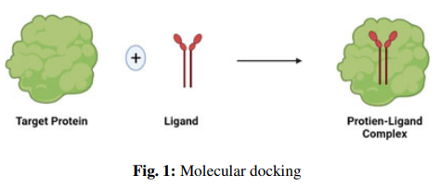
Docking comes in two different kinds.
1. Stiff docking
2. Adaptable docking

Stiff docking
We are looking for a three-dimensional rearrangement of one of the compounds that yields the best match to the other compounds in terms of scoring system characteristics, assuming the compounds are rigid. Receptor binding activity is not necessary for the development of the ligand's conformation.
Adaptable docking
We examine the molecules when anything is changing. How they are also evolving. We want to observe what is going on with the molecules while we discuss transformation. flexibility to recognize confirmations for the ligand and receptor molecules in the combination shown in Figure 3 below
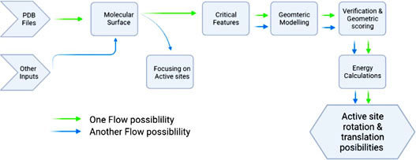

Major steps involved in mechanics of molecular docking
The method of examining the interactions between two molecules is called molecular docking. This process, known as "in-silico," is carried out on a computer. The large molecule in molecular docking is typically a protein receptor. The ligand molecule is the name of the tiny molecule. We can better understand how the ligand molecule interacts with the protein receptor by using molecular docking. In molecular docking, the ligand molecule can interact with the protein receptor. Molecular docking is a technique that aids in our comprehension of the interaction between the ligand molecule inhibitor and the protein receptor. Thus, the following phases are involved in the docking process:
Step I – preparation of protein: In order to obtain the three-dimensional structure, we first obtain the protein structure from the Protein Data Bank, or PDB. We must prepare the protein structure after obtaining it from the PDB. This implies that the water molecules within the protein must be eliminated. Additionally, we must ensure the stability of the charges. We must fill in any residues that may be missing from the protein. The protein's side chains must also be produced. All of this must be completed in accordance with the Protein's accessible parameters.
Step II –active site prediction: After the preparation: The location of the protein's active site must be determined while discussing proteins. The problem is that we are only interested in one of the receptor's active sites. Thus, we must select the one. If heteroatoms and water molecules are present, we typically eliminate them. This is due to the fact that they have no bearing on the protein's intended use. We only want to pay attention to the protein's location.
Step III The ligand is prepared in III. The ligand is available from somewhere. At this point, we must prepare the ligand using a variety of databases, including ZINC, Pub Chem, or I used the Chem sketch tool to draw this. I considered LIPINSKY'S RULE OF 5 when choosing the ligand. I can determine which ones are, like drugs, and which are not by using the Lipinski rule of five. The degree to which a molecule behaves like a real medicine helps me determine whether or not it will be successful. When a molecule complies with two or more of the requirements, something occurs. For selecting a ligand in accordance with Lipinsky's Rule:
- Five or less hydrogen bond donors;
- ten or fewer hydrogen bond acceptors;
- a molecular mass of less than 500 Da
- High lipophilicity (Logp not greater than 5)
- A molar refractivity of 40–130 is ideal.
The docking is done in Step IV. The protein and ligand are docked. This is a step in the interaction between the protein and the ligand. To determine how well the ligand and protein fit together, the ligand is positioned against the protein. We are examining the interactions between the docks and the protein. The scoring function assigns a score based on which docked ligand complex is selected.

Protein Apo Simulation: Although molecular dynamics simulation of biomolecules is frequently classified as computational chemistry, its scientific roots can be found in structural biology and polymer chemistry in the 1970s, when it was used to study the physics of local molecular properties like flexibility, distortion, and stabilization and relax early protein X-ray structures on short time scales. Mutation studies can now easily build models and perform quick simulations for hundreds of mutants, free-energy calculations are increasingly being used to provide better interaction energy estimates than what is possible with docking, and model-building web servers frequently offer automated energy minimization and refinement. Classical molecular dynamics simulations based on empirical models are important in these situations since the majority of attributes of interest are described by free energies, which typically need extensive sampling that traditional quantum chemistry approaches cannot give for big systems. These developments would not have been possible without extensive study into simulation algorithms, optimization, parallelization, and—above all—how to integrate simulations into modeling pipelines. Because it has made simulation and molecular modeling research more accessible to life science application researchers who are not specialists in simulation development, the creation of standardized molecular modeling programs like CHARMM, GROMOS, AMBER, and GROMACS has been essential. Achieving the highest simulation efficiency for the small- to medium-sized clusters found in our own research labs has been one of our primary long-term development goals for the GROMACS molecular simulation toolbox. These bundles all have complementing profiles and strengths. Because computational resources are typically restricted in those scenarios, it is sometimes preferable to use throughput algorithms with minimal parallelization that generate entire sets of simulations rather than maximizing performance in a single long simulation. However, we have recently paired this with improved parallel scaling5 to enable long simulations when specialized clusters or supercomputers are available for specific crucial situations.

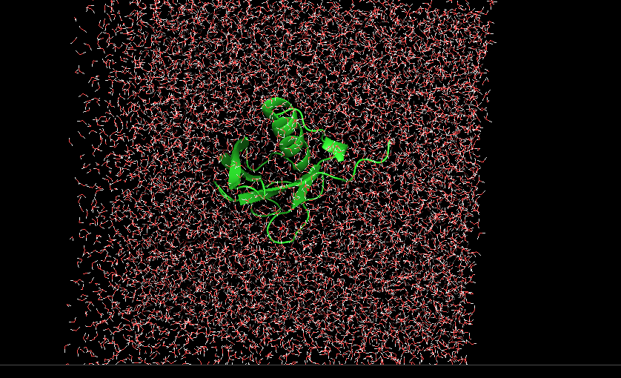
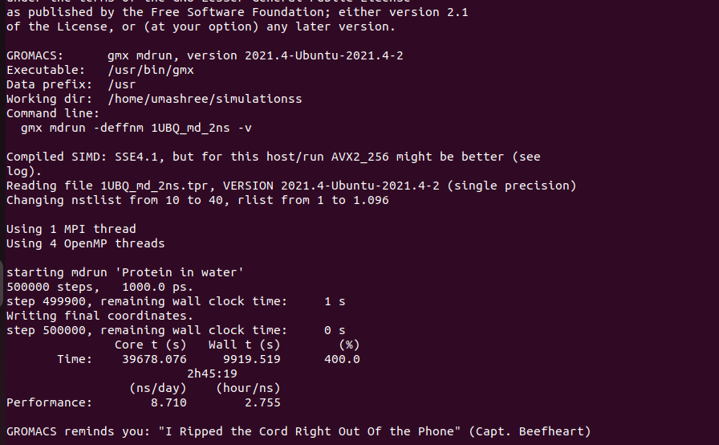
Results and Discussion
Fig 3: Final result obtained after Fig 4: Snapshot of apo protein molecular
Executing protein apo-simulation dynamics simulation in Explicit solvent

The apo protein's inherent conformational stability was effectively examined using molecular
dynamics (MD) modeling. After the protein was put in a box containing solvent molecules
(water), it underwent molecular dynamics simulation, equilibration, and energy minimization.
The Apo Protein's Structural Stability The protein maintained its broad tertiary structure
throughout the simulation, showing no indications of structural breakdown or global unfolding.
The protein is thermodynamically stable in its apo state, as evidenced by the secondary
structural elementsα-helices and loop regions remaining structured. The protein is
positioned in the center of the simulation box in the final photo, ensuring enough solvation and
proper box dimensions.

Solvent Distribution and System Equilibration
Effective protein solvation was demonstrated by the uniform distribution of water molecules surrounding the protein. The system obtained appropriate equilibration because there were no visible vacuum gaps or solvent clustering. In order to maintain native-like conformation during MD simulations, the water molecules created a stable hydration shell around the protein's surface. Flexibility in Conformity Simply looking at the simulated structure reveals that loops and surface-exposed areas are more flexible than the protein's core. This is expected for apo simulations because areas that might subsequently be involved in binding interactions would have more freedom in the absence of the ligand. The protein's core offers some structural stability because it is comparatively stiff.

Discussion: The apo molecular dynamics simulation aided in investigating the protein's inherent flexibility and stability in the absence of a ligand. The outcome shows that even though the protein was simulated without a ligand, it remained stable. The simulation is well-equilibrated when there is an equal amount of water surrounding the protein. Additionally, it is expected that an apo system will be more flexible than a ligand-bound system. One of the goals of ligand-bound simulation is to answer some of the questions left unresolved by earlier simulation study.
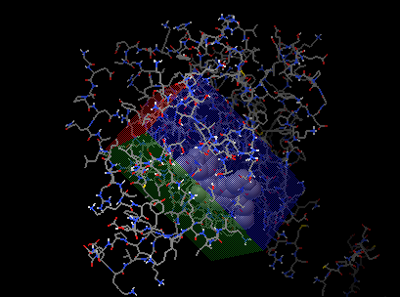
Docking Results: We performed protein-ligand docking using Auto Dock Vina. It provided us with nine potential ways for the ligand to attach to the protein. Predicted binding affinities ranged from -2.5 to -2.8 kcal/mol.
With an RMSD value of 0.000 Å and the lowest binding energy of -2.8 kcal/mol, Mode 1 was chosen. This indicates that in Mode 1, protein-ligand docking has a stable and advantageous binding state. Higher binding energies and (RMSD) root mean square deviation values were found in the other protein-ligand docking positions.

Fig 5: Snapshot of Grid box created around the Ligand using Auto dock tool
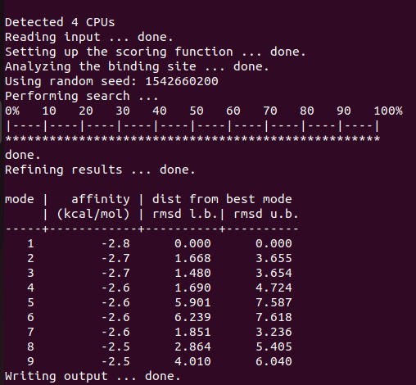
This demonstrates that although there are methods for the ligand to be aligned with the protein in protein-ligand docking, these are not as stable as the optimal protein-ligand docking pose. Overall, the findings show that the ligand has a moderate binding affinity for the protein's binding site.
The ligand may fit into the target protein's site quite well, according to the molecular docking analysis. The ligand forms a strong bond with the protein. The ligand had the lowest energy when we examined its docking, indicating a good interaction between the ligand and the protein. The ligand can wander around a little inside the protein since it can attach to the protein in a variety of ways with comparable energies. The ligand may not interact with the protein in a very specific way because the energies of the docking poses are quite close, indicating that the ligand does not actually favor one way of binding over another.
Fig 6: Obtained Docking score
Here, the ligand, the protein, and the molecular docking research are all crucial. We are concentrating on the ligand and the protein. Although the ligand can interact with the protein, its modest binding strength suggests that structural tweaking may be necessary to improve binding stability and specificity. All things considered, the docking study offers initial understanding of ligand–protein interactions and forms the foundation for additional research, including ligand modification, molecular dynamics simulations, or experimental validation.
Applications
The protein may become active or cease to function as a result of the molecular docking contacts. A protein can also function when a ligand attaches itself to it. Prevent it from operating. Because molecular docking interactions can influence a protein's behavior, they are crucial. The molecular docking interactions can be influenced by the binding of the protein and the ligand. Proteins interact with other molecules, such as ligands, through molecular docking interactions.
We examine how things interact with one another when we discuss agonism or antagonism. One technique to comprehend this is molecular docking. It enables us to observe how well certain molecules fit together. To learn more about agonism or antagonism, we employ molecular docking. For this type of research on agonism or antagonism, molecular docking is incredibly helpful.
1. Hit Recognition (Virtual Screening)
2. Optimization of Leads (Drug discovery)
3. The use of bioremediation
4. KA prediction (biological activity?)
5. Predicting binding sites (blind docking)
6. Protein deorphaning
7. Interactions between proteins and nucleic acids
8. Looking for protein targets' lead structures
9. Research on Structure and Function
10. Enzymatic Reaction Mechanisms
11. Engineering proteins
Next Generation Sequencing
The raw sequence data from the NGS is the first step in the NGS bioinformatics process. The NGS bioinformatics pipeline truly begins here. It does something with the sequence after obtaining it. The NGS bioinformatics pipeline begins with the raw sequence. Both the data generated by the sequencer and the data it formats are crucial. The data is generated by the sequencer. After that, the data is formatted. The sequencer uses the data in this way. software from the sequencing company, like Illumina. Finding the variations in the sample will be entirely handled by the process. After that, it will provide details about those variations, such as the gene they belong to and the impact they have on the gene. This is crucial to comprehending the functions of the variants. For the Illumina sample, the pipeline will handle each of these processes. Variants such as missense, nonsense, or splice-site are examined. We also examine how it occurs. Next, we determine whether the variation is linked to any illnesses. This procedure seeks to Let's compile a list of potential variations. After that, we will manually review these potential variations. We'll do it this way.
1. Every candidate variant will be examined
2. Each candidate variant will be examined individually.

The goal is to check all the candidate variants. In this manner, we can be certain of the potential variations. selected with clinical actionability in mind. Ion Torrent sequencing technology, a kind of device that aids in determining the order of DNA sequences, is used in several clinical laboratories. Because it enables scientists to do numerous tests and studies on human and other living organisms' DNA, this technology is extremely significant. Ion Torrent sequencing technology is used in labs to diagnose diseases and create medications. Laboratories use Ion Torrent sequencing technique. comes in kits with related software for analysis, doing tasks by hand doesn't require much effort. We concentrate on the review itself in this review. Because Illumina sequencing technology is more practical for me, I prefer it. It contains many details on Illumina sequencing technology that I believe are significant. I like to use Illumina sequencing technology. The fact that data is widely used and can be analyzed in a variety of ways is crucial. There are still numerous options for analyzing these kinds of data, whether the clinical laboratory employs Base Space, a cloud computing provider, or an internal computing infrastructure, even if Illumina offers a platform for analysis called Base Space. We must examine FASTQ files in order to obtain the genomic sequence reads that are used by the majority of analytic algorithms. These FASTQ files are just text files with a quality score for each base, known as Phred. Sequencing alignment is then performed using this quality score. The likelihood that the base is incorrect is used to calculate the Phred quality score. A score of 20, for instance, is comparable to a cutoff point. This indicates that the base has a 1% chance of being incorrect. A higher score indicates better quality. These FASTQ files and genomic sequence readings are used in our investigation. Because they are used to determine which bases are more accurate, these quality scores are significant. In the study of the quality scores, bases with a quality score are given greater weight because they are thought to be superior. This means that when we look at the outcomes, the quality scores assist us determine which bases to trust more. The bases having a quality score are given more weight in the analysis thanks to the quality scores genotype prediction. Sample pooling within the same run is possible with multiplex sequencing. In a procedure known as demultiplexing, each sample has a distinct adapter sequence that can be utilized to segregate readings by sample/adapter. The bcl2fastq application receives these adaptor sequences in a comma-separated (CSV) file together with additional sample-related data like sample ID and project name. The FASTQ files that were produced automatically are now prepared for bioinformatic analysis.

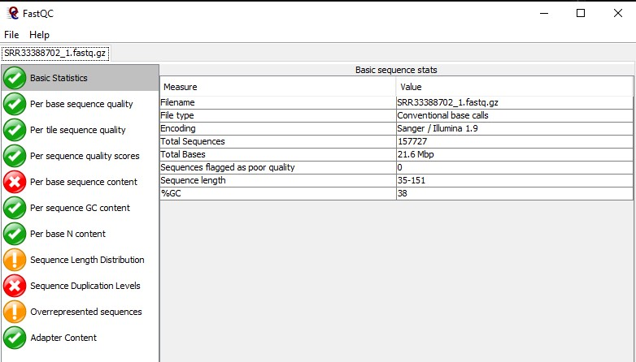
Fig 7: Raw data exported for quality check using FASTQC website

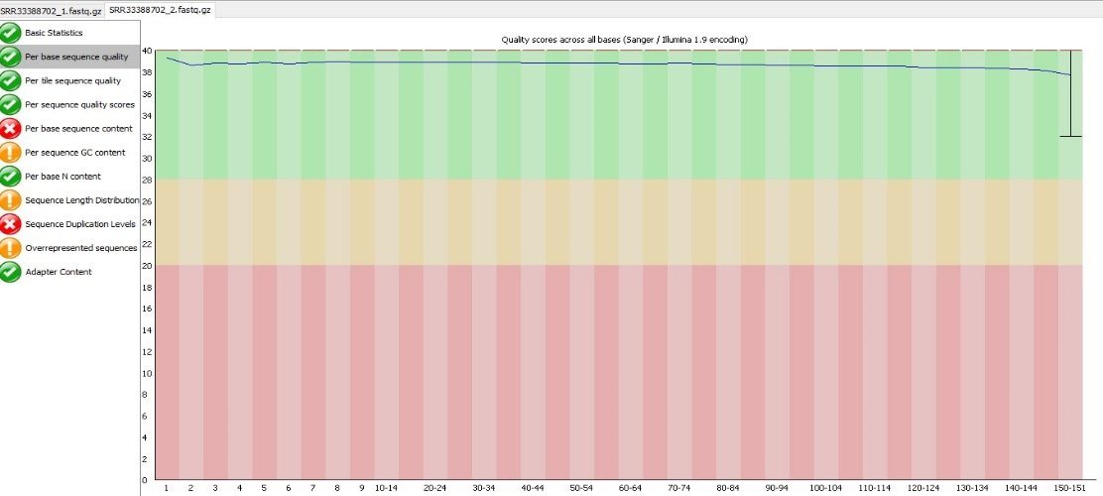

Fig 8: Per base sequence quality, In the above colours, Green- Good quality, yellow- Average, Red-Bad quality and the blue line passed in green segment is the Sequence line which represents the good quality of the same which used for the further analysis.
Methodology
Without personnel, bioinformatics analysis might be very difficult. Automated analytic pipelines can be useful in this situation. Data processing is possible using these pipelines. Provide results as soon as possible. Numerous organizations and research initiatives have already established pipelines for the analysis of viral NGS data.
Some of these systems are particularly adept at combining information from sources such as metagenomes or samples from patients infected with a particular virus. The pipelines perform a few stages for some types of viruses. They take the information. Utilize it as a guide to help you create an image of the virus's appearance Additionally, they attempt to create an image of the virus from the ground up without consulting any references. We refer to this as de novo assembly. Both of these procedures make advantage of viral NGS data. SARS-CoV-2 data is now being used by the system. This information passes through the reference recruiting module, a component of the system. The Wuhan-Hu-1 SARS-CoV-2 reference strain is used by the system in this module to compile the SARS-CoV-2 data. To achieve this, the system makes use of the specifics of this strain, MN908947. The SARS-CoV-2 data is then partially eliminated by the system. Thirty nucleotides are removed from each end of the data. A program named Cutadapt, version 2.3, is used for this. These sections were eliminated because certain labs sequence the SARS-CoV-2 data using unique techniques. Some sequence information may be retained by these techniques, which might complicate the study The method uses a tool named Bowtie2 aligner, version 2.1.0, to align the SARS-CoV-2 data once the superfluous sections are eliminated. This aids in visualizing the SARS-CoV-2 data. The SARS-CoV-2 data is crucial to comprehending the virus. How it operates. After that, sorted.bam files are created using Sam Tools (version 1.10), which are subsequently used to create bedGraph files. After creating.vcf files using Freebayes (version 1.0.2), a consensus fasta sequence file for the SARS-CoV-2 specimens is assembled using BEDTools (version 2.27.1).
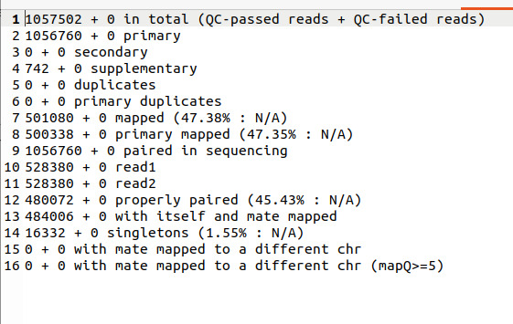
The SAM/BAM format is often compatible with these tools. Next, create a VCF file, sometimes called a variation calling format file. Large-scale initiatives like the 1000 Genomes Project employ the VCF file. The current version of the VCF file is 4.2. The VCF file is a text document. There are lines that provide information, a header line, and lines that contain the actual data. Each of these data lines provides information about the location on the chromosome, the base that is typically found there, and the base or bases that the tool has discovered. Because it makes the information included in the VCF file easier to grasp, the VCF format is crucial. Additionally, the format includes sample genotype data at each spot. VCFtools make it simple to work with VCF files, such as combining numerous files or extracting SNPs from particular sections.
Fig 9: snapshot of sam tools flagstat output
FastQC v.0.11.5 was used to quality check the raw sequenced reads, while Trimmomatic v.0.36 was used to filter for adapter regions and low-quality reads. SPAde’s v.3.13 was used to assemble the de novo genome, while Prokka v.2.1.1 annotation pipeline, Rapid Annotation utilizing Subsytems Technology (RAST) server v.2.0, and PATRIC annotation tool v.3.6.29 were used for annotation.

Results and Discussions
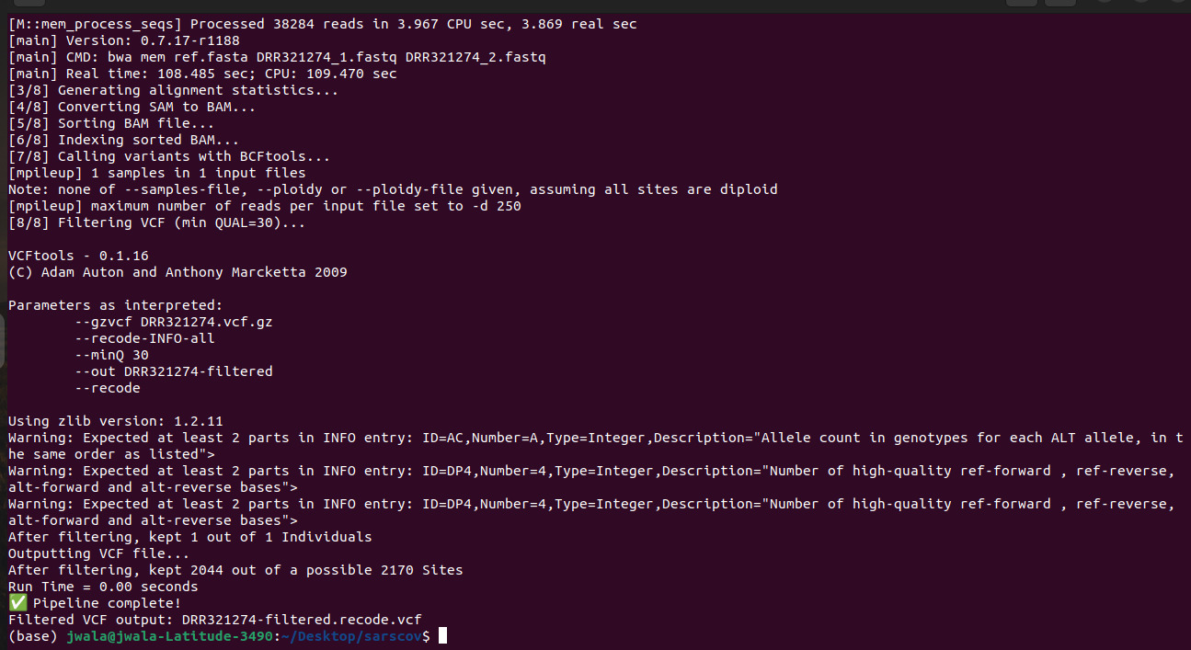
Fig 10: Snapshot of final execution page of NGS

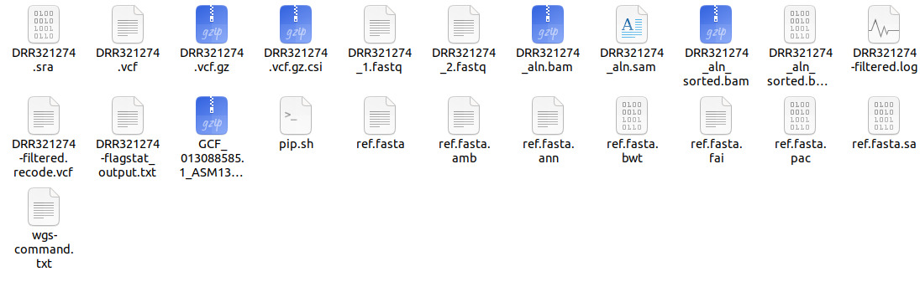Fig 11: required files which are generated after the execution of pipeline
The NGS analysis pipeline was completed successfully and error-free, according to the end execution page. Every stage in the analytical process was completed in a methodical and sequential manner. The raw sequencing data was of a satisfactory quality, according to the Quality Control phase. High base quality was indicated by a significant percentage of the reads, guaranteeing high-quality sequencing outcomes. The filtered reads were correctly matched to the reference genome throughout the processing and alignment stage. The accuracy of the aligned results and the quality of the library preparation are guaranteed by high alignment efficiency and pairing the successful processing of the BAM file shows that the aligned sequences were properly sorted and indexed for additional processing. Genomic variations such as SNPs and Indels were identified during the variant calling step. The step's successful completion shows that the depth and quality of the sequencing were sufficient to identify the variations. The NGS analytic pipeline completes its jobs precisely and effectively, according to the final execution step.

Reference
1. S Agarwal, R Mehrotra - JSM chem, 2016 - researchgate.net. No Title.
2. Behjati, S. & Tarpey, P. S. What is next generation sequencing? Arch Dis Child Educ Pract Ed 98, 236–238 (2013).
3. Raval, K. & Ganatra, T. Basics, types and applications of molecular docking: A review. IP International Journal of Comprehensive and Advanced Pharmacology 7, 12–16 (2022).
4. Chaudhary KK, M. N. (2016). A Review on Molecular Docking: Novel Tool for Drug Discovery.
5. Pronk, S. et al. GROMACS 4.5: a high-throughput and highly parallel open source molecular simulation toolkit. Bioinformatics 29, 845–854 (2013).
6. SoRelle, J. A., Wachsmann, M. & Cantarel, B. L. Assembling and Validating Bioinformatic Pipelines for Next-Generation Sequencing Clinical Assays. Arch Pathol Lab Med 144, 1118–1130 (2020).
7. Wagner, D. D. et al. VPipe: an Automated Bioinformatics Platform for Assembly and Management of Viral Next-Generation Sequencing Data. Microbiol Spectr 10, (2022).
8. SoRelle, J. A., Wachsmann, M. & Cantarel, B. L. Assembling and Validating Bioinformatic Pipelines for Next-Generation Sequencing Clinical Assays. Arch Pathol Lab Med 144, 1118–1130 (2020).
9. Madaha, E. L. et al. Whole-genome sequence of multi-drug resistant Pseudomonas aeruginosa strains UY1PSABAL and UY1PSABAL2 isolated from human broncho-alveolar lavage, Yaoundé, Cameroon. PLoS One 15, e0238390 (2020).

10. Insilicomics Pvt.Lim, manual for Protein apo simulation and NGS

